**PRACTICAL-1**

**AIM**

To implement Cloud-based infrastructures and services, it is required to set up the complete system requirements. Researchers & industry-based developers can focus on specific system design issues that they want to investigate, without taking more concerned about the low-level details so the Cloudsim is very much useful for these activities and it can support simulation environment to implement cloud-based infrastructure solutions. Overview of Cloudsim functionalities:

• Support for modeling and simulation of large-scale Cloud computing data centers

• support for modeling and simulation of virtualized server hosts, with customizable policies for provisioning host resources to virtual machines

• support for modeling and simulation of data center network topologies and message-passing applications

• support for dynamic insertion of simulation elements, stop and resume of simulation

• support for user-defined policies for allocation of hosts to virtual machines and policies for allocation of host resources to virtual machines

Perform Cloud Computing Set up using Cloudsim Tool:

1. Introduction to Cloudsim tool.

2. Perform Installation steps of Cloudsim on NetBeans.

**IMPLEMENTATION**

**Introduction to Cloudsim Tool.**

CloudSim is a simulation toolkit that supports the modeling and simulation of the core functionality of cloud, like job/task queue, processing of events, creation of cloud entities(datacenter, datacenter brokers, etc), communication between different entities, implementation of broker policies, etc. This toolkit allows to:

* Test application services in a repeatable and controllable environment.
* Tune the system bottlenecks before deploying apps in an actual cloud.
* Experiment with different workload mix and resource performance scenarios on simulated infrastructure for developing and testing adaptive application provisioning techniques

Core features of CloudSim are:

* The Support of modeling and simulation of large scale computing environment as federated cloud data centers, virtualized server hosts, with customizable policies for provisioning host resources to virtual machines and energy-aware computational resources
* It is a self-contained platform for modeling cloud’s service brokers, provisioning, and allocation policies.
* It supports the simulation of network connections among simulated system elements.
* Support for simulation of federated cloud environment, that inter-networks resources from both private and public domains.
* Availability of a virtualization engine that aids in the creation and management of multiple independent and co-hosted virtual services on a data center node.
* Flexibility to switch between space shared and time shared allocation of processing cores to virtualized services.

**General Steps to follow in the Cloudsim**

Initiate the cloudsim simulation.

● create a datacenter.

● create a datacenter broker.

● create VMs/cloudlet add it to respective lists.

● submit vm and cloudlet list to borker.

● start simulation.

● stop simulation.

● print the end results.

**INSTALLATION-STEPS FOR NETBEANS:**

* You need to have a setup file of the NetBeans JAVA into your setup.

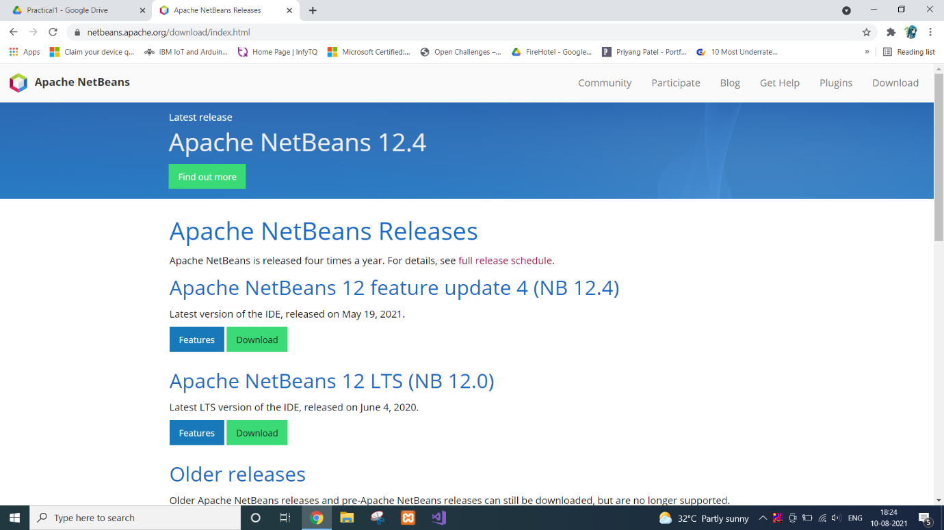

* You can download any type of setup as per your requirements from the above mention web page.
* Right-click on the setup or you can Double-Click on the setup by using the mouse.
* Click on the next option.

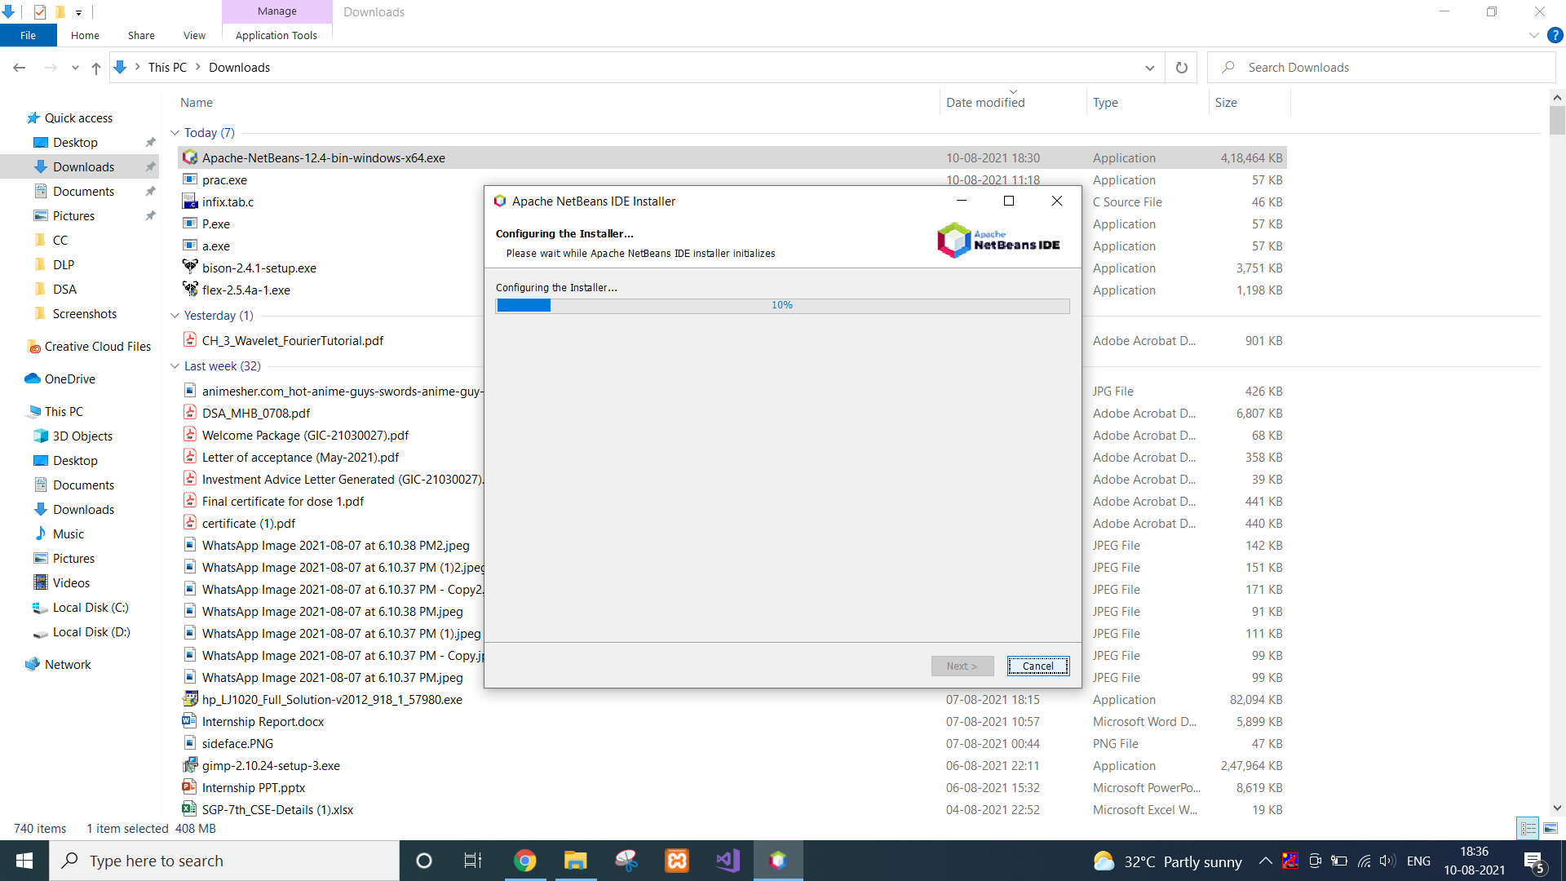

* Click on the “Install” button.
* Wait for the while till the time the setup is properly Installed into the Computer
* After complication of the setup you can click on the “Finish” button or you can also register the Software, for Further Assistance because it is a Free Software.
* Now you can start the NetBeans for further use.

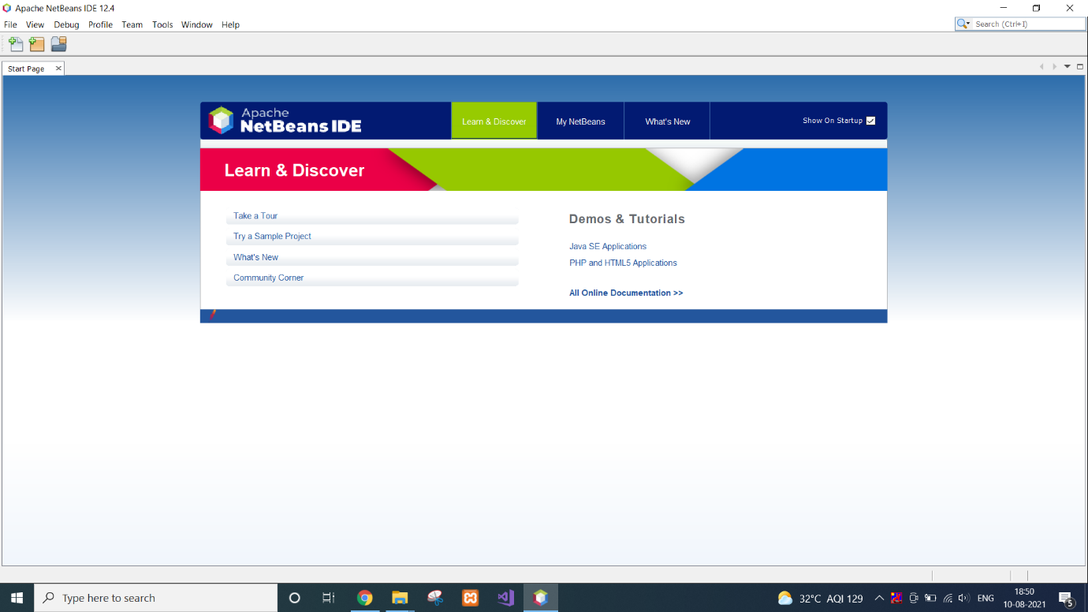

**INSTALLATION-STEPS FOR CLOUDSIM:**

* Open Netbeans, Go to file–>>new project.

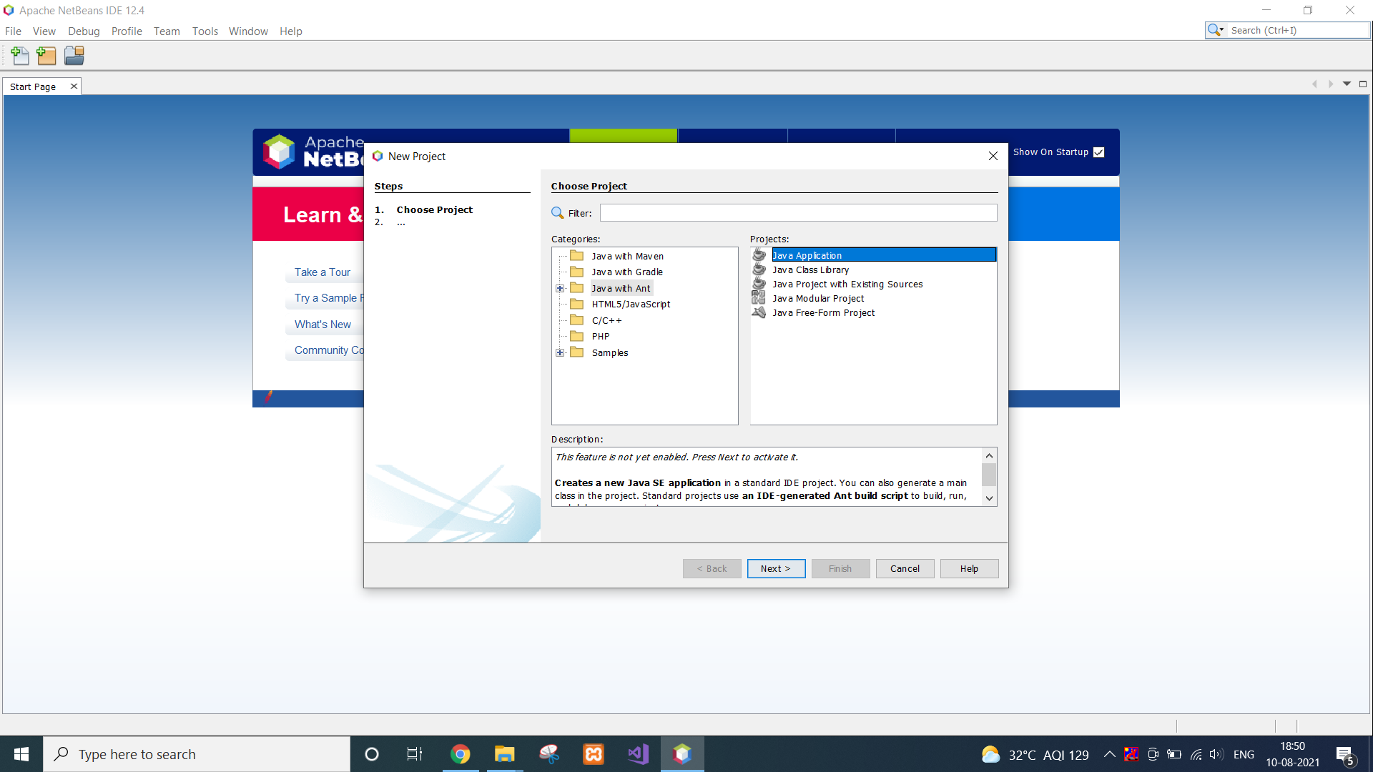

* select “Java with Ant” folder then select first option Java Application, Press next
* Now give a name to the project as you wish.

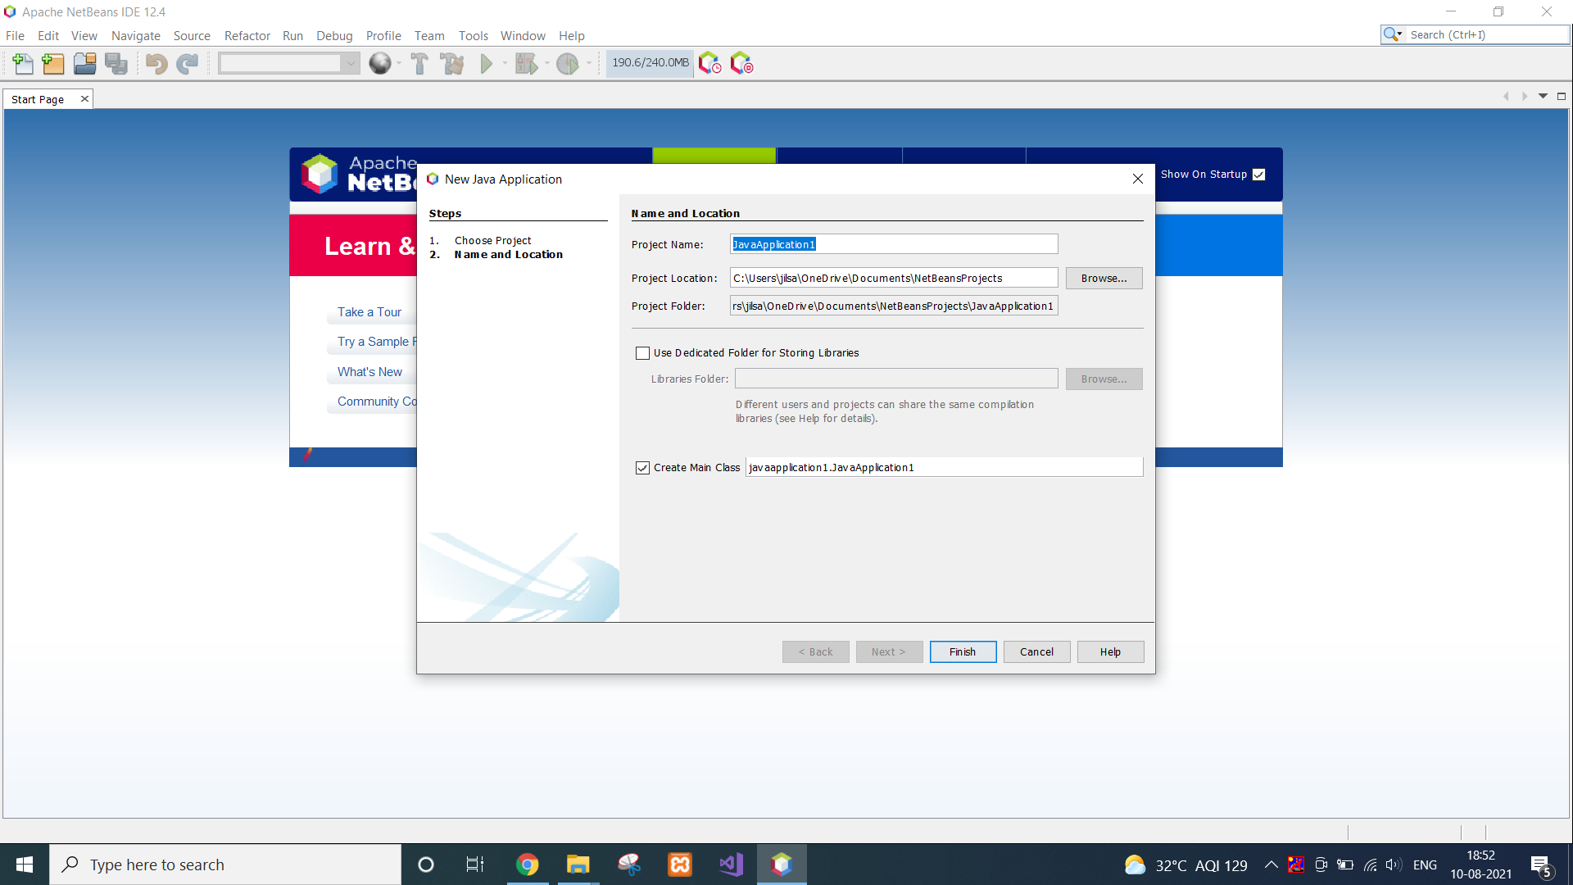

* Go to library, right click on it, a menu will come, click on “Add jars/Folders”

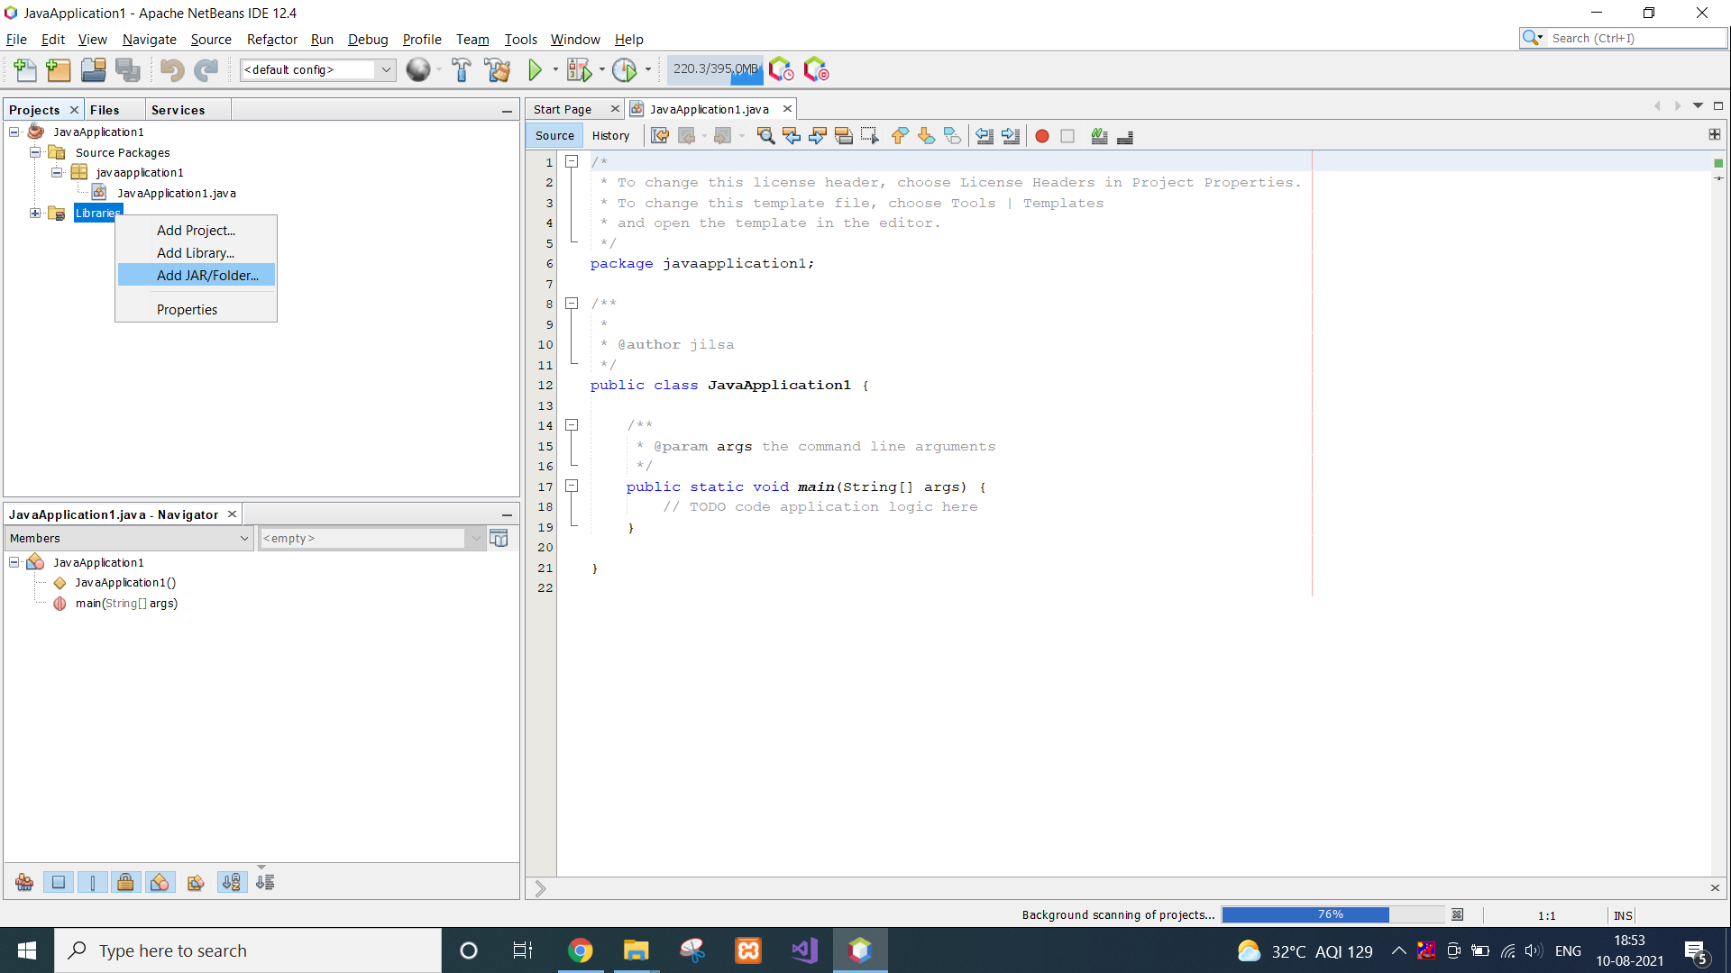

* Now browse the cloudsim folder which you have extracted from zip file .and go to that folder and select “cloudsim-3.0.3.jar”.

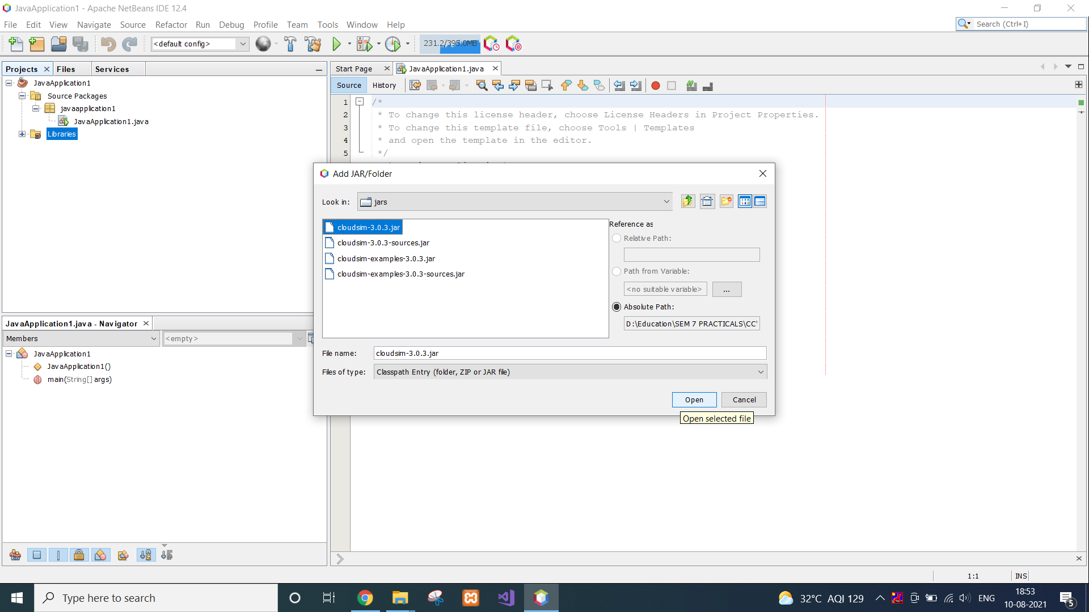

* That’s how cloudsim can be installed in Netbeans.

**CONCLUSION**

In this practical, we learnt about Netbeans and Cloudsim. We installed both the tools in our system.